Introduction
Wind energy has become a central pillar of decarbonisation strategies worldwide, and its continued expansion depends on containing the levelised cost of energy (LCOE) to remain competitive with other forms of generation. Reliability is a decisive determinant of that cost: over a typical 20-year working life, operation and maintenance (O&M) accounts for approximately 10–15% of a wind farm’s total investment, a share that rises to 20–25% for offshore farms (Deng et al., 2017). The sector’s growth is, moreover, increasingly concentrated at its most demanding frontier. Installed offshore capacity is projected to rise from 10.5 GW in 2020 to 27.5 GW by 2026 (Udo & Muhammad, 2021), while the United Kingdom’s net-zero pathway envisages 75 GW of offshore capacity, equivalent to roughly 7,500 large turbines(Donnelly et al., 2024). Rising turbine ratings and the migration to more remote, less accessible sites intensify the pressure on LCOE.
Within the turbine, the gearbox is a major reliability concern for the sector as a whole. It has one of the highest failure rates among drivetrain sub-assemblies (Shafiee & Dinmohammadi, 2014; Figure 1-1), its failures are particularly consequential because of complex repair procedures, high replacement costs and prolonged downtime combine to produce substantial revenue losses (Feng et al., 2013). Indicative replacement costs reach approximately US$628,000 for a 5 MW gearbox (Yang, 2013). These consequences are greatest offshore. Offshore turbines operate in a harsher, less accessible environment and fail more frequently than their onshore counterparts, at an average rate of 1.38 against
1.22 failures per turbine per year(Shafiee & Dinmohammadi, 2014).

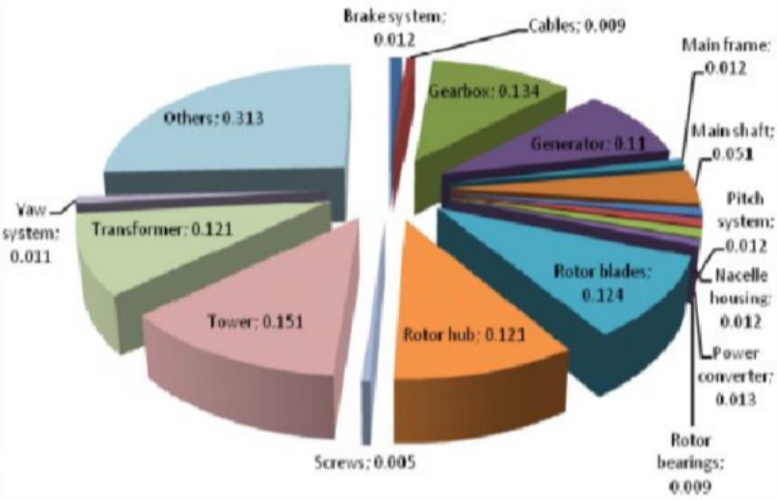

(a)
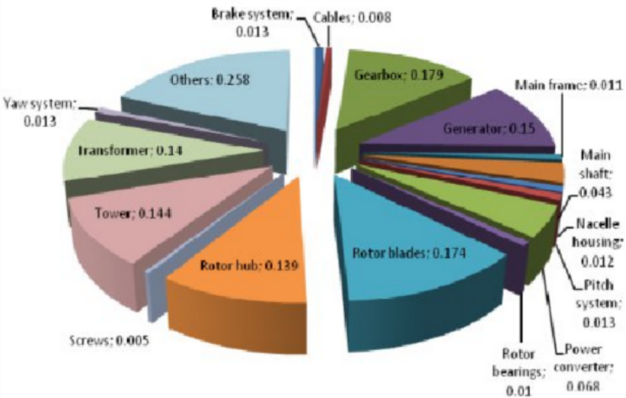

(b)

Figure 1-1 Failure rates of wind turbine sub-assemblies for (a) onshore and (b) offshore systems.(Shafiee & Dinmohammadi, 2014)
O&M therefore accounts a large share of lifecycle expenditure, typically 16–25% of the cost of electricity (Udo & Muhammad, 2021) and around 27% more than for equivalent onshore systems (Shafiee & Dinmohammadi, 2014). Major gearbox interventions offshore additionally depend on scarce heavy-lift vessels and favourable weather windows that extend non-operational periods far beyond the repair itself. Curtailing unplanned downtime therefore translates directly into a lower cost of energy, its reduction has been estimated to lower the cost of

offshore electricity by approximately 10%(Donnelly et al., 2024). Figure 1.2 shows that the gearbox is the leading contributor to cumulative turbine downtime across a large sample of the operating fleet.
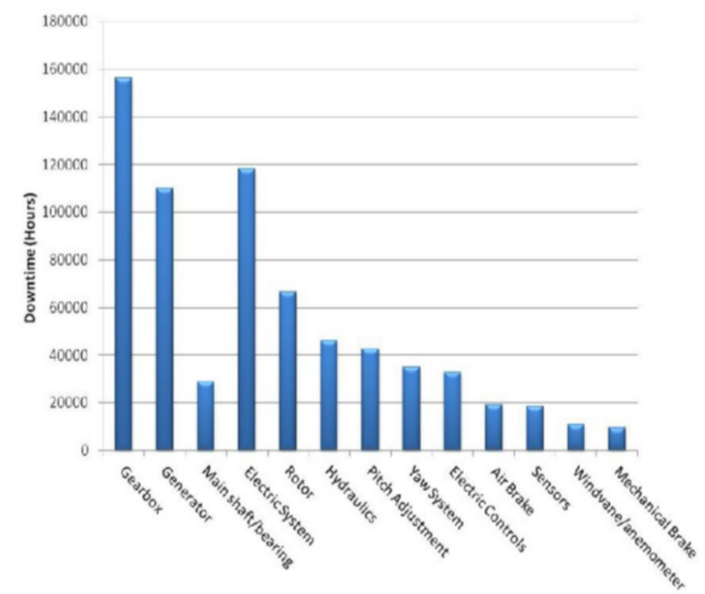

Figure 1.2. Wind turbine subsystems cumulative downtime, covering approximately 27,000 turbines (500 kW–5 MW) reported for 2003–2009
(Yang, 2013)

The economic importance of gearbox reliability, established across the wind fleet and further amplified offshore makes its early and effective monitoring a priority for reducing O&M costs and improving turbine availability.

The Condition Monitoring practices
The scale and inaccessibility of modern wind assets make reactive, run-to-failure maintenance economically impractical, motivating a shift towards condition-based and predictive maintenance in which interventions are scheduled according to actual component health. Adopting such strategies can reduce maintenance costs by approximately 20% to 25% compared with fixed-interval

schedules (Pandit et al., 2023), but their effectiveness depends on the quality of the underlying monitoring data.
Two monitoring foundations dominate, and their characteristics are compared in Table 1.2. Dedicated condition monitoring systems (CMS), typically based on high-frequency vibration measurement, are sensitive and well established for detecting incipient mechanical faults(S. Sheng, 2012) however, they are susceptible to environmental noise, and their hardware overhead additional, intrusively installed sensors adding capital and maintenance cost to every turbine constrains their scalability across large fleets(Pandit et al., 2023; Santolamazza et al., 2021). By contrast, supervisory control and data acquisition (SCADA) systems are already installed on virtually all modern turbines and record operational data continuously at no additional hardware cost(Santolamazza et al., 2021), an inherently low-cost and scalable foundation whose advantage becomes increasingly decisive as fleets grow (Tautz‐Weinert & Watson, 2017). As Table 1.2 shows, this advantage carries a diagnostic price: SCADA data are typically stored as ten-minute averages, discarding the high-frequency content on which vibration analysis depends, and their suitability for reliable fault diagnosis is not guaranteed by availability alone(Murgia et al., 2023; Pandit et al., 2023).
Table 1-2 Comparison of wind turbine condition monitoring data sources

 | SCADA system | CMS | Other techniques
Data types | Wind speed and direction, rotor speed, active power, pitch and yaw angle, nacelle and ambient temperature, gearbox oil temperature, generator winding/bearing temperature, transformer temperature, and other electrical signals  (L. Sheng et al., 2025) | Vibration signals acquired at key drivetrain components (L. Sheng et al., 2025) | Acoustic emission, oil debris analysis, electrical impedance and signature data, guided-wave excitation, torque measurement, shock pulse, infrared thermography and image data  (L. Sheng et al., 2025)
Advantages | Widely installed as standard, so data | Particularly well suited | Rich in data types, with strong

 | acquisition incurs minimal additional cost; readily collected online in real time; covers a rich set of operational variables (Sheng et al., 2025).  Temperature channels can additionally support condition monitoring of main, generator and gearbox high-speed-stage bearings (Yang, 2013) | to detecting a range of drivetrain faults, with strong diagnostic performance (Sheng et al., 2025); spectral analysis can partially localise damaged gearbox components (Yang, 2013) | detection performance for specific fault classes (Sheng et al., 2025); for example, oil debris counts are sensitive to gearbox component damage, and filter element analysis can reveal wear debris missed by conventional oil sampling (Yang, 2013)
Disadvantages | Low sampling rate degrades high- | Confined to a single | Narrow applicability, as each data
 | frequency diagnostic content, | data modality; requires | type typically detects only specific
 | yielding weak fault signatures that | costly retrofitting of | fault classes and requires dedicated
 | are frequently insufficient for direct | dedicated vibration | acquisition equipment (Sheng et al.,
 | fault diagnosis (Sheng et al., 2025); | sensors; contact- | 2025); several techniques are offline
 | consequently limited in pinpointing | based measurement | or periodic, cannot localise damage,
 | the specific damaged subsystem or | imposes an additional | or remain validated only at test-rig
 | component (Yang, 2013) | burden on the | scale (Yang, 2013)
 |  | equipment (Sheng et
 |  | al., 2025); diagnosis is
 |  | further challenged by
 |  | low-speed
 |  | components and
 |  | variable-speed,
 |  | variable-load
 |  | operation (Yang,
 |  | 2013)
  - Problem Statement, Research Motivation and Research Gaps
The availability of SCADA data resolves the question of monitoring infrastructure but not that of monitoring value. Most data-driven approaches are designed to flag statistical anomalies, yet an anomaly alert is not, in itself, a diagnosis: it indicates that behaviour has deviated from the expected without explaining why, or what should be done in response. The economic weight of this interpretive step is considerable: identifying the fault has been reported to consume 70–90% of total fault-handling time, with the repair itself accounting for only the remaining 10–30% (Deng et al., 2017). Two related shortcomings prevent current SCADA-based methods from closing this gap between detection and actionable maintenance decision-making.

The first is a diagnostic interpretation gap. Many models generate alerts that carry limited physical insight, and post-hoc explainability techniques typically reveal only which input features an algorithm relied upon rather than the physical mechanism responsible for the deviation(Cummins et al., 2024). The black-box character of high-performing models further discourages operators from adopting them in practice (Ghahfarokhi et al., 2025). This matters because appropriate operator reliance depends on interpretable and trustworthy information; where such information is absent, automation is misused or rejected (Lee & See, 2004). The noisy nature of real SCADA alarms compounds this problem, as high detection sensitivity often comes at the expense of numerous false positives(Velandia-Cardenas et al., 2021). Therefore, translating detection into maintenance action requires interpretable diagnostics that directly link model outputs to physical causes.
The second is a multi-variable thermal residual analysis gap. Gearbox degradation is a thermal process that manifests across several coupled signals. Therefore, a coordinated pattern, rather than an isolated reading, often carries the diagnostic information(Qiu et al., 2016). Despite this, many methods evaluate variables independently and neglect subsystem interactions, contributing to missed detections and false alarms (Jiang et al., 2022). Furthermore, the causal structure between predictor and target variables influences the performance of normal behaviour models (Felgueira et al., 2019). Approaches that disregard the underlying thermal physics tend to generalise poorly(Bai et al., 2024). Consequently, a more complete representation of gearbox health requires assessing residuals across multiple thermally coupled variables, rather than one signal at a time.
In response to these two gaps, this research investigates whether a multi-target normal behaviour model combined with a physics-informed interpretation layer derived from failure modes and effects analysis (FMEA) can improve the interpretability and practical usefulness of SCADA-based gearbox monitoring. This FMEA-informed layer is proposed not as an established solution, but as an interpretability pathway under investigation. It maps coordinated thermal residual

patterns to candidate physical failure mechanisms. Additionally, the causal separation of predictor and target variables serves as a supporting design principle to promote robust and physically meaningful residuals. These gaps and the proposed response define the aim and objectives formalised in the following section.

Research Aim and Objectives
The aim of this research is to develop and evaluate a SCADA-based gearbox condition monitoring framework. This framework integrates multi-target normal behaviour modelling with a physics-informed, FMEA-based interpretation layer. The goal is to improve both the multi-signal representation of gearbox degradation and the physical interpretability of fault-detection outputs. This aim directly addresses the multi-variable thermal residual analysis and diagnostic interpretation gaps identified in Section 1.3.
This aim is pursued through four sequential objectives:

    - To engineer a clean, healthy-state SCADA dataset and apply a causal separation of predictor and target variables, establishing a physically meaningful basis for modelling.
    - To develop a multi-target normal behaviour model that predicts gearbox oil and bearing temperatures under healthy operation, evaluating its predictive accuracy using root mean square error (RMSE), mean absolute error (MAE), and mean absolute percentage error (MAPE) and to verify the physical credibility of the learned relationships through SHAP-based explainability analysis..
    - To generate and process residual streams from model outputs, characterising deviations that indicate abnormal gearbox behaviour.
    - To formulate and investigate an FMEA-informed interpretation framework that maps coordinated thermal residual patterns to candidate physical failure mechanisms, assessing it through detection indicators such as lead time and false-alarm rate.

Research Questions
The aim and objectives define three research questions, each addressing a core element of the proposed framework: healthy-state modelling, multi-signal residual reasoning, and physical interpretation.
RQ1. To what extent can a multi-target normal behaviour model accurately represent healthy gearbox thermal behaviour using SCADA data?
RQ2. Do coordinated residual patterns across multiple thermally coupled signals provide more informative diagnostic evidence than isolated-signal monitoring?
RQ3. To what extent can an FMEA-informed interpretation of these residuals enrich SCADA-based fault-detection outputs with physically plausible candidate failure mechanisms?
RQ1 establishes the modelling foundation, RQ2 tests the multi-signal response to Gap 2, and RQ3 examines the interpretability response to Gap 1.
A clear scope boundary applies throughout. Detection performance is evaluated quantitatively against maintenance and alarm records. However, the available ground truth cannot verify the diagnostic accuracy of mechanism-level interpretations. As a result, these interpretations are evaluated only for physical plausibility and internal consistency.
The importance of answering these questions, and the overall dissertation structure, are outlined in the following section.

Expected Contributions and Dissertation Structure
Scientifically, the research is expected to contribute a multi-target thermal residual analysis that represents gearbox degradation across coupled signals rather than in isolation, and to demonstrate how data-driven normal behaviour modelling can be combined with engineering knowledge, through an FMEA-informed layer, to improve the physical interpretability of SCADA diagnostics. These are advanced as expected contributions to be investigated rather than as

guaranteed outcomes. Industrially, if the framework proves effective, it may strengthen maintenance decision support by linking anomaly detection to candidate failure mechanisms, and support more appropriate operator reliance on automated monitoring(Lee & See, 2004). If it enables earlier and better-founded intervention, it also offers the potential to reduce offshore downtime and its associated cost of energy (Donnelly et al., 2024), without requiring additional monitoring hardware. The remainder of the dissertation is structured to address the research questions in sequence. Chapter 2 substantiates the two gaps through a critical review; Chapter 3 details the five-phase methodology that operationalises the objectives; Chapter 4 reports normal behaviour-model accuracy and explainability (RQ1) and the behaviour of coordinated residuals (RQ2); Chapter 5 evaluates the FMEA-informed interpretation (RQ3) against detection performance and its limitations; and Chapter 6 draws conclusions, revisiting the aim and the extent to which the contributions were realised.

References
Bai, X., Han, S., Kang, Z., Tao, T., Pang, C., Dai, S., & Liu, Y. (2024). Wind turbine gearbox oil temperature feature extraction and condition monitoring based on energy flow. Applied Energy, 371, 123687. https://doi.org/10.1016/j.apenergy.2024.123687
Cummins, L., Sommers, A., Ramezani, S. B., Mittal, S., Jabour, J., Seale, M., & Rahimi, S. (2024). Explainable Predictive Maintenance: A Survey of Current Methods, Challenges and Opportunities. IEEE Access, 12, 57574–57602. https://doi.org/10.1109/ACCESS.2024.3391130
Deng, X.-W., Gao, Q.-S., Zhang, C., Hu, D., & Yang, T. (2017). Rule—Based Fault Diagnosis Expert System for Wind Turbine. ITM Web of Conferences, 11, 07005. https://doi.org/10.1051/itmconf/20171107005
Donnelly, O., Anderson, F., & Carroll, J. (2024). Operation and maintenance cost comparison between 15&thinsp;MW direct-drive and medium-speed offshore wind turbines. Wind Energy Science, 9(6), 1345–1362. https://doi.org/10.5194/wes-9-1345-2024
Felgueira, T., Rodrigues, S., Perone, C. S., & Castro, R. (2019). The Impact of Feature Causality on Normal Behaviour Models for SCADA-based Wind Turbine Fault Detection (arXiv:1906.12329). arXiv. https://doi.org/10.48550/arXiv.1906.12329
Feng, Y., Qiu, Y., Crabtree, C. J., Long, H., & Tavner, P. J. (2013). Monitoring wind turbine gearboxes. Wind Energy, 16(5), 728–740. https://doi.org/10.1002/we.1521

Ghahfarokhi, A. F., Schäfer, J., Wagner, M. F., & Dorronsoro, B. (2025). Explainable Artificial Intelligence for Time Series Using Attention Mechanism: Application to Wind Turbine Fault Detection. IEEE Access, 13, 180613–180631. https://doi.org/10.1109/ACCESS.2025.3621003
Jiang, G., Li, W., Fan, W., He, Q., & Xie, P. (2022). TempGNN: A Temperature-Based Graph Neural Network Model for System-Level Monitoring of Wind Turbines With SCADA Data. IEEE Sensors Journal, 22(23), 22894–22907. https://doi.org/10.1109/JSEN.2022.3213551
Lee, J. D., & See, K. A. (2004). Trust in Automation: Designing for Appropriate Reliance. Human Factors, 46(1), 50–80. https://doi.org/10.1518/hfes.46.1.50_30392
Murgia, A., Verbeke, R., Tsiporkova, E., Terzi, L., & Astolfi, D. (2023).

Discussion on the Suitability of SCADA-Based Condition Monitoring for Wind Turbine Fault Diagnosis through Temperature Data Analysis.
Energies, 16(2), 620. https://doi.org/10.3390/en16020620

Pandit, R., Astolfi, D., Hong, J., Infield, D., & Santos, M. (2023). SCADA data for wind turbine data-driven condition/performance monitoring: A review on state-of-art, challenges and future trends. Wind Engineering, 47(2), 422–441. https://doi.org/10.1177/0309524X221124031
Qiu, Y., Feng, Y., Sun, J., Zhang, W., & Infield, D. (2016). Applying thermophysics for wind turbine drivetrain fault diagnosis using SCADA data. IET Renewable Power Generation, 10(5), 661–668. https://doi.org/10.1049/iet-rpg.2015.0160

Santolamazza, A., Dadi, D., & Introna, V. (2021). A Data-Mining Approach for Wind Turbine Fault Detection Based on SCADA Data Analysis Using Artificial Neural Networks. Energies, 14(7), 1845. https://doi.org/10.3390/en14071845
Shafiee, M., & Dinmohammadi, F. (2014). An FMEA-Based Risk Assessment Approach for Wind Turbine Systems: A Comparative Study of Onshore and Offshore. Energies, 7(2), 619–642. https://doi.org/10.3390/en7020619
Sheng, L., Li, C., Gao, M., Xi, X., & Zhou, D. (2025). A review of SCADA-based condition monitoring for wind turbines via artificial neural networks.
Neurocomputing, 633, 129830. https://doi.org/10.1016/j.neucom.2025.129830
Sheng, S. (2012, January 7). Wind Turbine Gearbox Condition Monitoring Round Robin Study—Vibration Analysis (Report NREL/TP-5000-54530). National Renewable Energy Laboratory (U.S.). UNT Digital Library. https://doi.org/10.2172/1048981
Tautz‐Weinert, J., & Watson, S. J. (2017). Using SCADA data for wind turbine condition monitoring – a review. IET Renewable Power Generation, 11(4), 382–394. https://doi.org/10.1049/iet-rpg.2016.0248
Udo, W., & Muhammad, Y. (2021). Data-Driven Predictive Maintenance of Wind Turbine Based on SCADA Data. IEEE Access, 9, 162370–162388. https://doi.org/10.1109/ACCESS.2021.3132684

Velandia-Cardenas, C., Vidal, Y., & Pozo, F. (2021). Wind Turbine Fault Detection Using Highly Imbalanced Real SCADA Data. Energies, 14(6), 1728. https://doi.org/10.3390/en14061728
Yang, W. (2013). Wind Turbine Drivetrain Condition Monitoring  An Overview.

